CREATING HIVE TABLE FROM HBASE LOOK-UP TABLES

----------------------------------------------------------------------------------------------------------------------

1. **Station_Geo_Map**

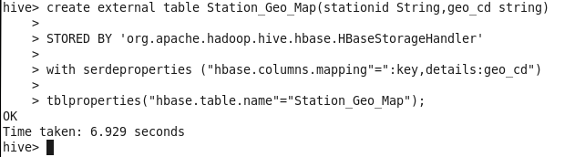

**Output**

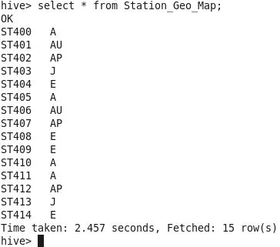

-----------------------------------------------------------------------------------------------------------------------------------

1. **Subscribed Users (Start)**

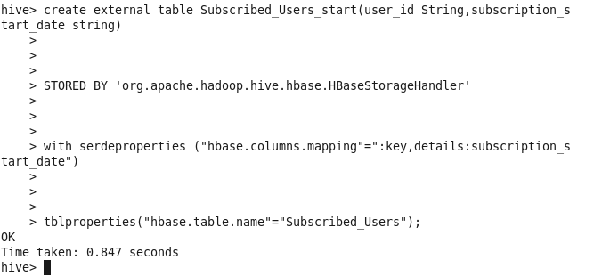

**Output**

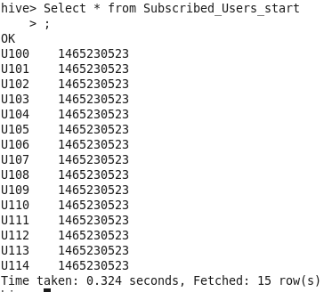

---------------------------------------------------------------------------------------------------------------------------

1. **Subscribed Users(End)**

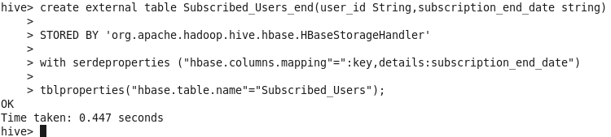

**Output**

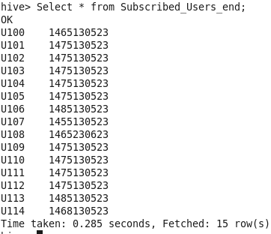

--------------------------------------------------------------------------------------------------------------------------

------------------------------------------------------------------------------------------------------------------------

1. **Song_Artist_Map**

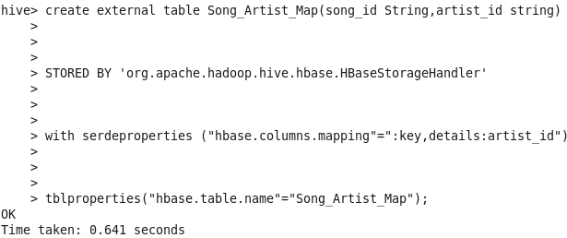

**Output**

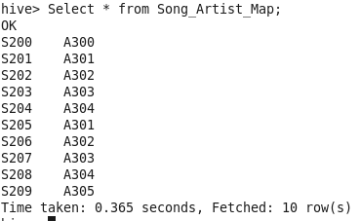

-----------------------------------------------------------------------------------------------------------------

--------------------------------------------------------------------------------------------------------------------------

1. **User_Artist_Map**

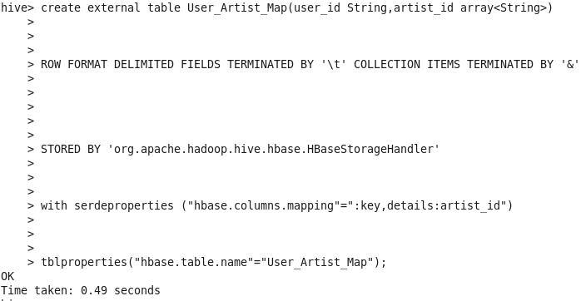

**Output**



